Fitbit registration

Made 17.07.2018.

To use the API of Fitbit, you need to generate API credentials.

1. Go to a Fitbit page <https://www.fitbit.com/signup> , enter you data and click SignUp.

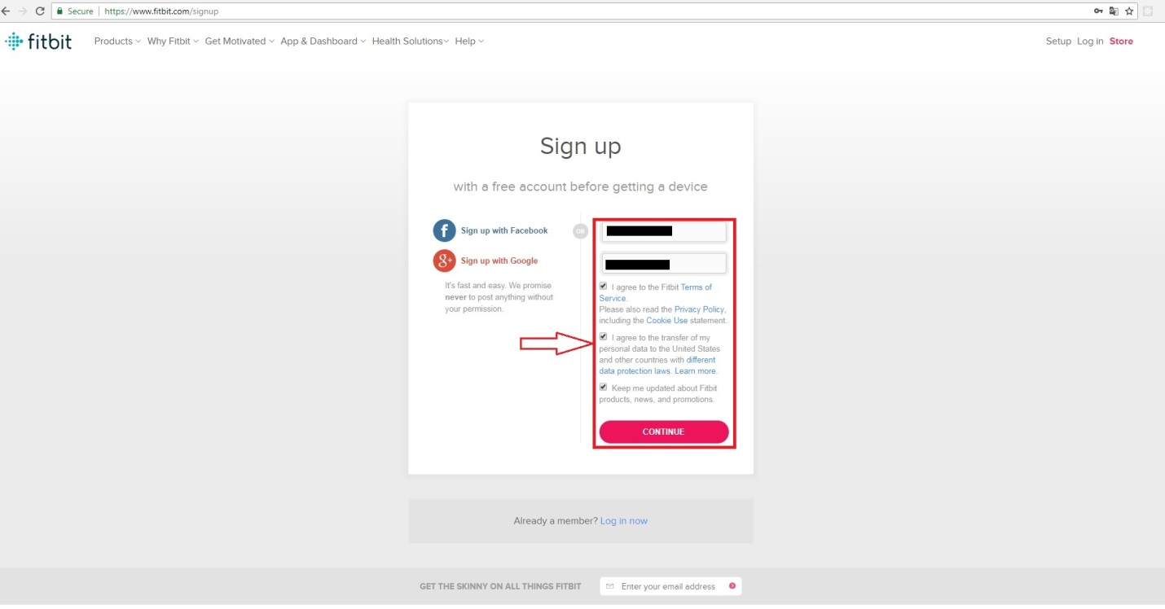

1. Enter information about yourself and click Save Profile.

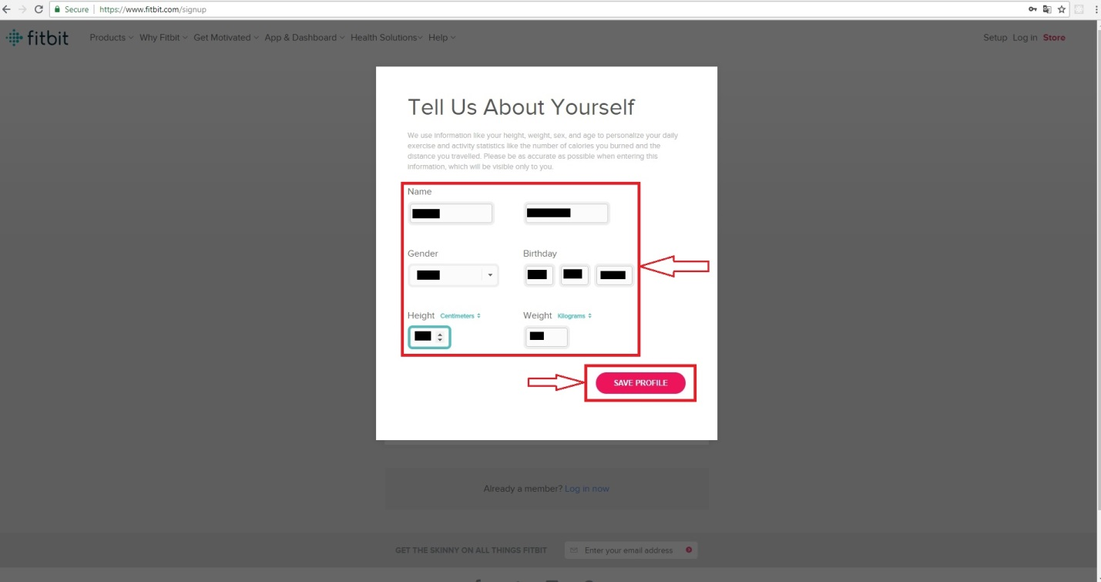

1. You need to confirm you e-mail address. Enter information about your e-mail account, then in a letter from Fitbit click Verify Your E-mail.

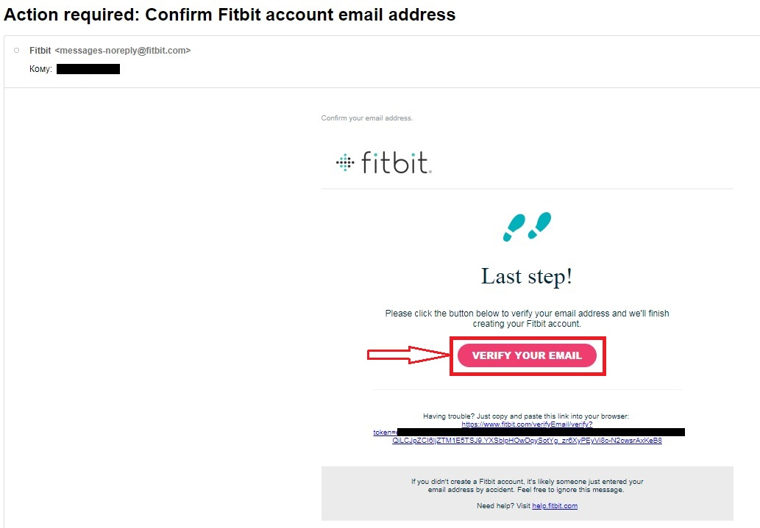

1. Go to the developers page <https://dev.fitbit.com/apps/new> , enter your Fitbit account data and click Log in.

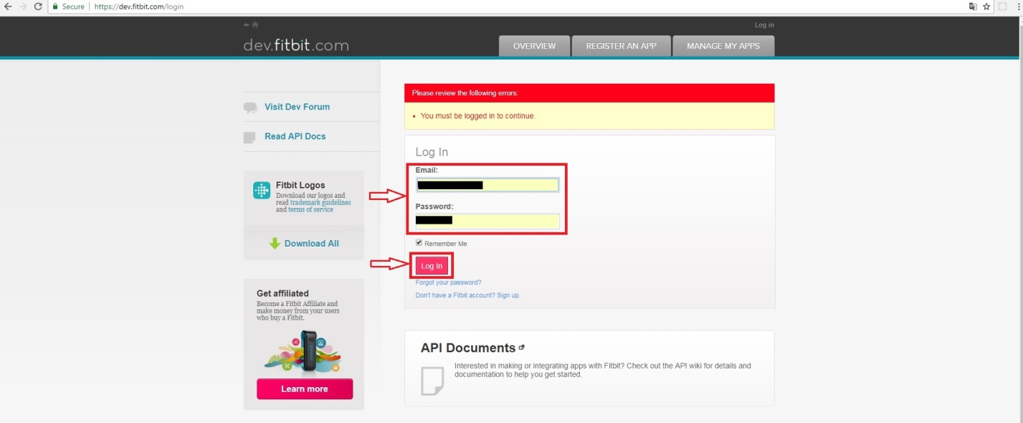

1. Enter information about your app and click Register.

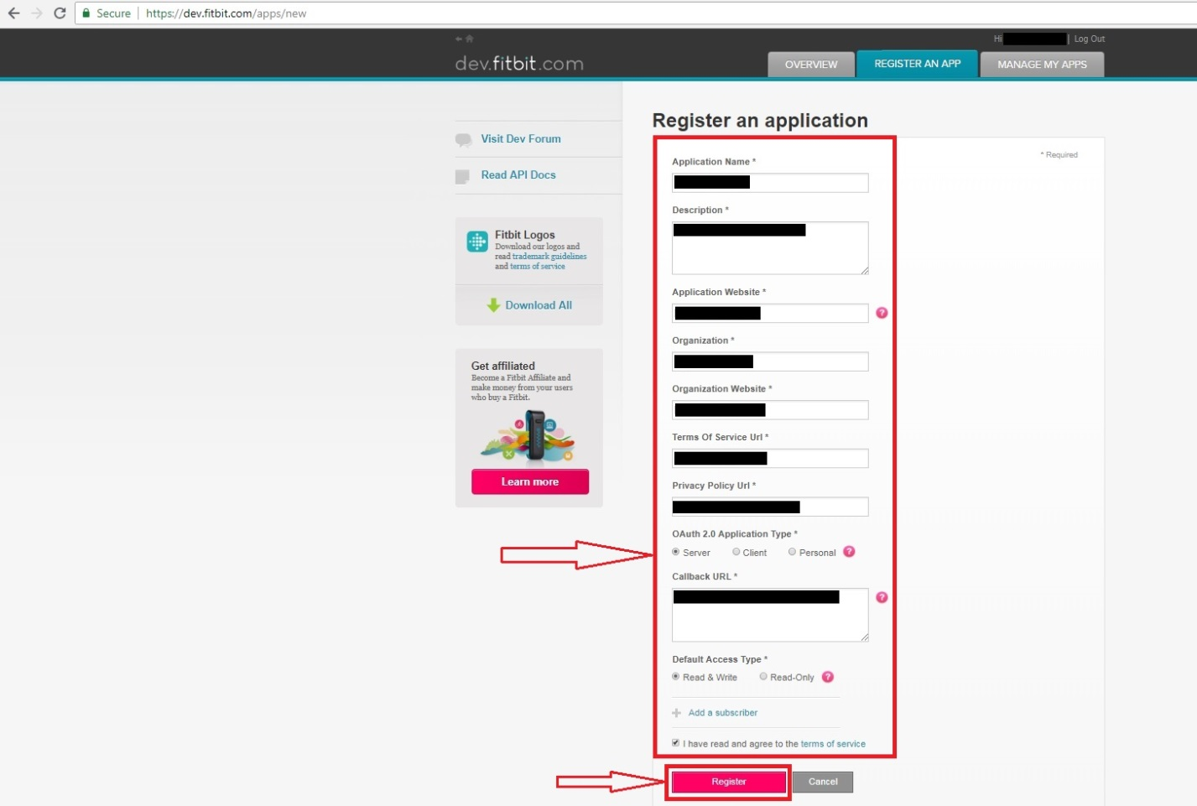

1. Yours API credentials are ready.

